

Department of Psychiatry & Behavioral Neuroscience

Charles R. Schuster Memorial Lecture:
Lessons Learned from Studying Psychoactive Drugs

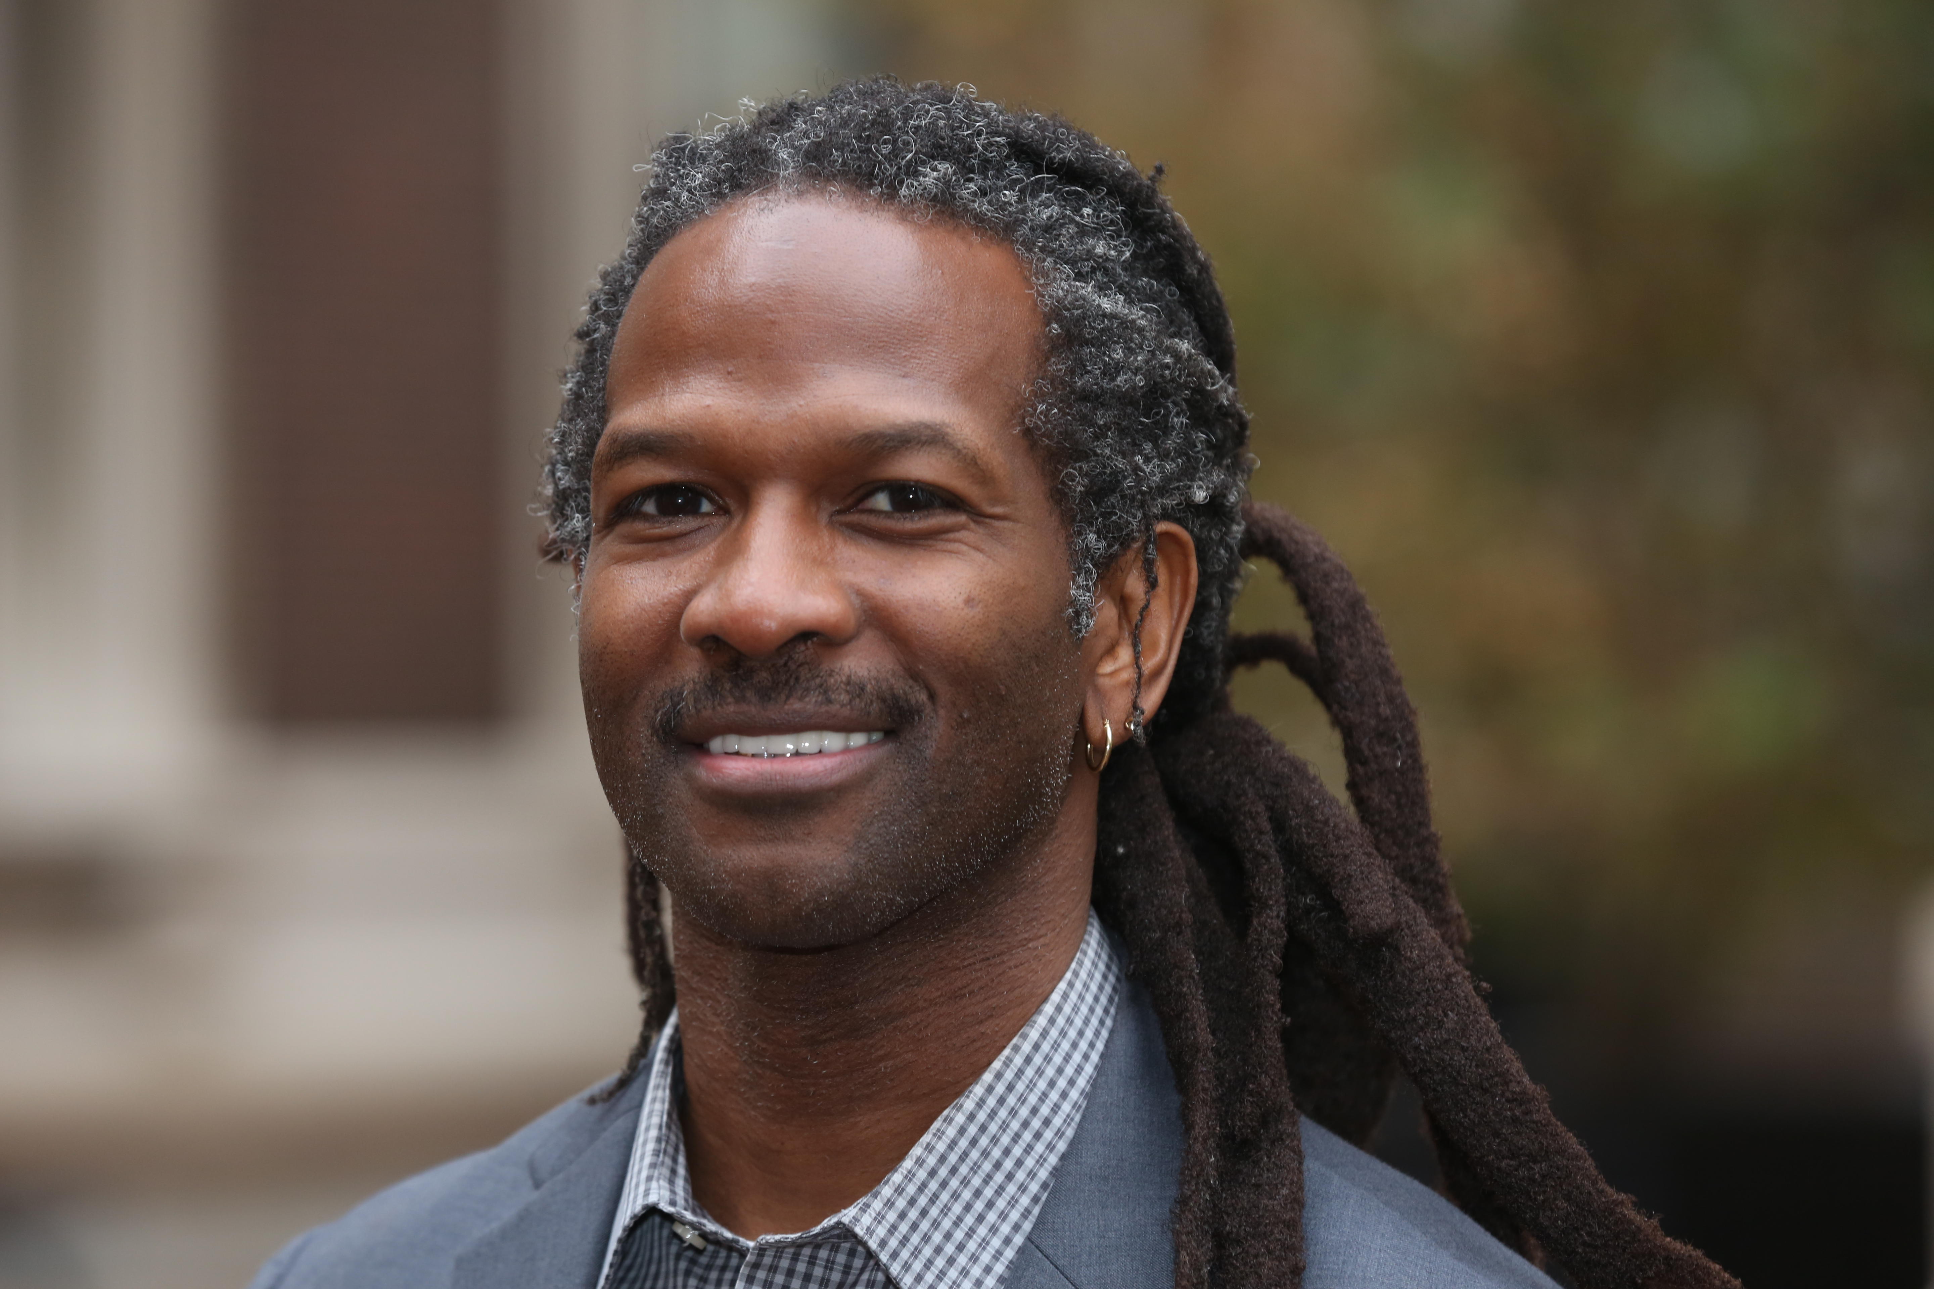

Carl L. Hart, Ph.D.
Ziff Professor of Psychology (in Psychiatry)
Chair, Department of Psychology, Columbia University
Thursday, September 12th, 2019
Dora De Lee Hall, L-168
12:00 – 1:30 PM

Dr. Hart conducts research on the human psychopharmacology of addiction. He is the author of the widely acclaimed book High Price: A Neuroscientist's Journey of Self-Discovery That Challenges Everything You Know About Drugs and Society, for which he won the E.O. Wilson Literary Science Writing Award in 2014. He is an outspoken critic of current theories and policies om drug abuse, and has spoken on myths about drug addictions at a TEDMED event.. He is featured in the documentary The House I Live In (2012 film), and has given testimony to the United States Congress' Committee On Oversight and Government Reform.

Accreditation & Credit Designation Statement: The University Of Chicago Pritzker School Of Medicine is accredited by the Accreditation Council for Continuing Medical Education to provide continuing medical education for physicians. The University Of Chicago Pritzker School Of Medicine designates this live activity for a maximum of 1.5 AMA PRA Category 1 CreditsTM. Physicians should claim only the credit commensurate with the extent of their participation in the activity.

