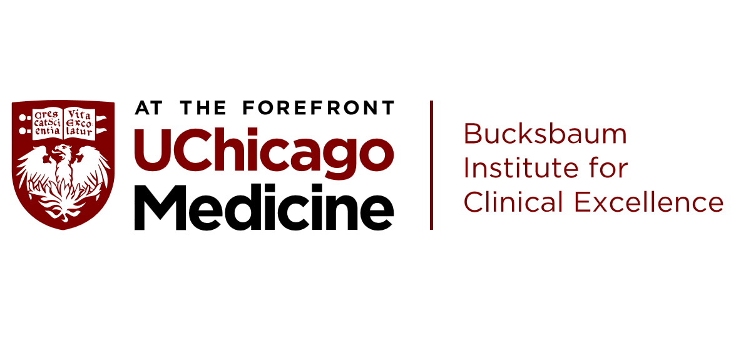

Department of Psychiatry & Behavioral Neuroscience

Truong Vu Memorial Lecture in Psycho-Oncology:

Translational biobehavioral oncology research: Applied psychoneuroimmunology in hematopoietic cell transplantation

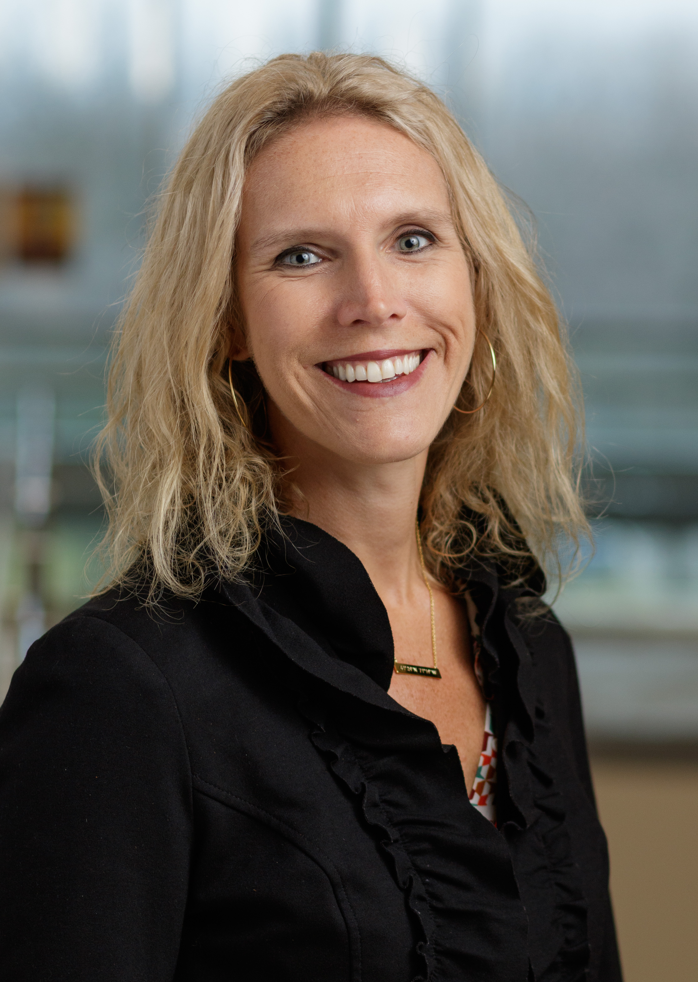

Jennifer M. Knight, MD, MS, FACLP
Associate Professor of Psychiatry, Medicine, and Microbiology & Immunology
Divisions of Consultation Liaison Psychiatry and Hematology/Oncology
Medical Director, Cancer Center Psycho-Oncology Program
Medical College of Wisconsin
Date: Thursday, April 8th, 2021
Time: 12:00 – 1:30 PM
Location: ZOOM Conference

Accreditation & Credit Designation Statement:

The University of Chicago Pritzker School of Medicine is accredited by the Accreditation Council for Continuing Medical Education to provide continuing medical education for physicians.

The University of Chicago Pritzker School of Medicine designates this live activity for a maximum of 1.5 AMA PRA Category 1 CreditsTM. Physicians should claim only the credit commensurate with the extent of their participation in the activity.

